**Week 3 Mandatory Exercises - Spring Core & Spring Data JPA**

# Exercise 1: Configuring a Basic Spring Application

## AppConfig.java

@Configuration  
public class AppConfig {  
 @Bean  
 public MessageService messageService() {  
 return new MessageService();  
 }  
}

## MessageService.java

public class MessageService {  
 public String getMessage() {  
 return "Hello from Spring!";  
 }  
}

## MainApp.java

public class MainApp {  
 public static void main(String[] args) {  
 ApplicationContext context = new AnnotationConfigApplicationContext(AppConfig.class);  
 MessageService service = context.getBean(MessageService.class);  
 System.out.println(service.getMessage());  
 }}

OUTPUT: 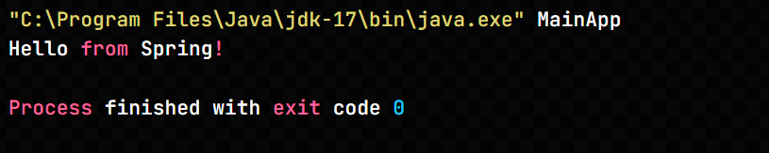

# Exercise 2: Implementing Dependency Injection

## Student.java

public class Student {  
 private Address address;  
  
 public Student(Address address) {  
 this.address = address;  
 }  
  
 public void setAddress(Address address) {  
 this.address = address;  
 }  
  
 public void display() {  
 address.showAddress();  
 }  
}

## Address.java

public class Address {  
 public void showAddress() {  
 System.out.println("Address: Bangalore, India");  
 }  
}

## AppConfig.java

@Configuration  
public class AppConfig {  
 @Bean  
 public Address address() {  
 return new Address();  
 }  
  
 @Bean  
 public Student student() {  
 return new Student(address()); // Constructor Injection  
 }  
}

Output Screenshot: 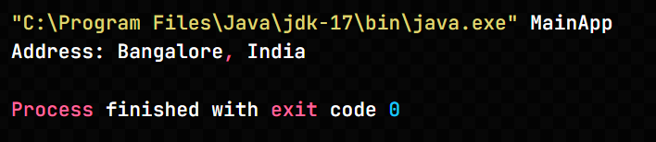

**Exercise 4: Creating and Configuring a Maven Project**

## pom.xml (dependencies snippet)

<dependencies>  
 <dependency>  
 <groupId>org.springframework</groupId>  
 <artifactId>spring-context</artifactId>  
 <version>5.2.9.RELEASE</version>  
 </dependency>  
</dependencies>

Output Screenshot: